Monitoring Task

Task Description:

Install Prometheus and Grafana on a Linux EC2 machine, connect Prometheus to Grafana, and create a dashboard to view metrics.

Prometheus created
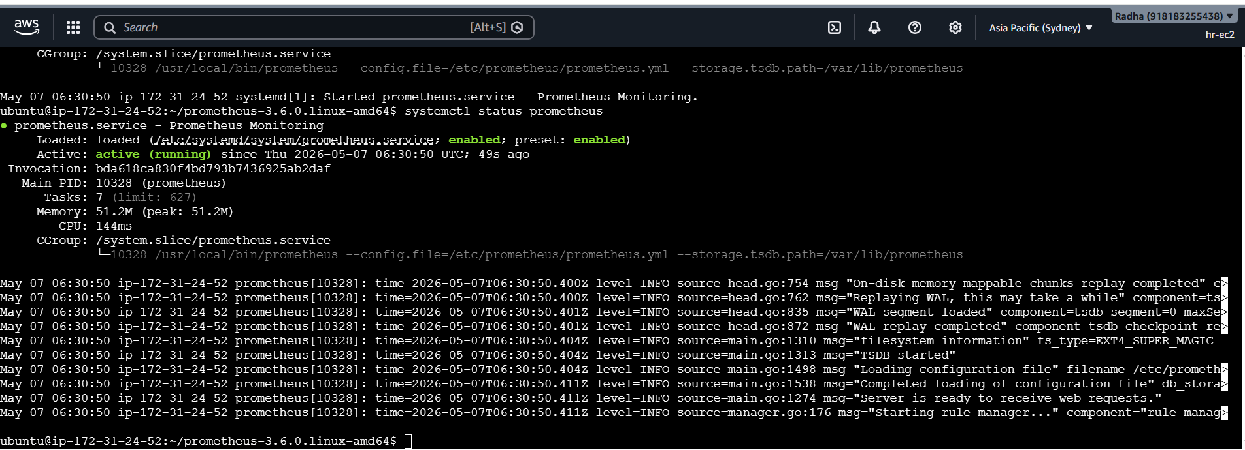
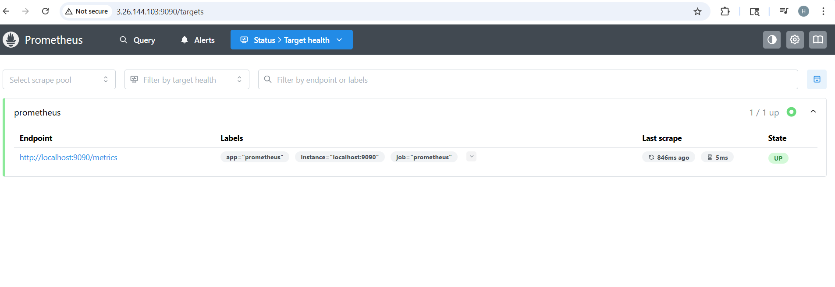
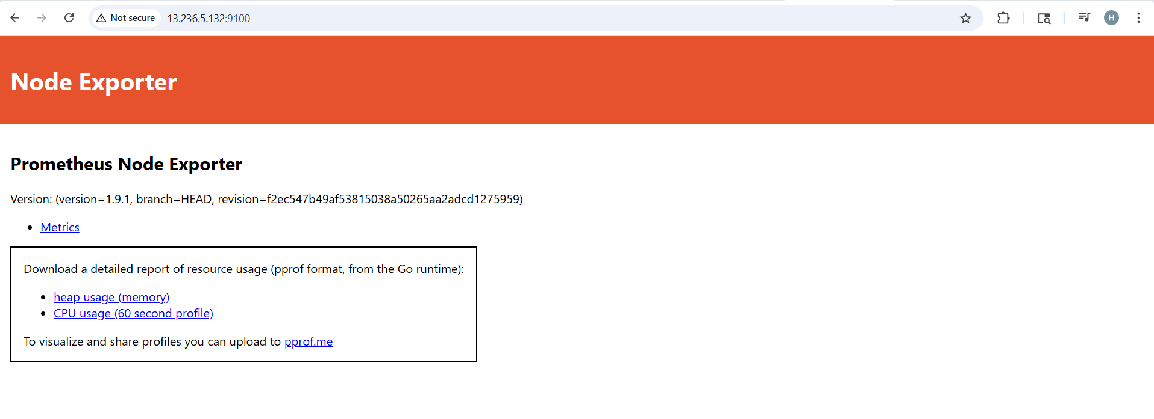
Node exporter added
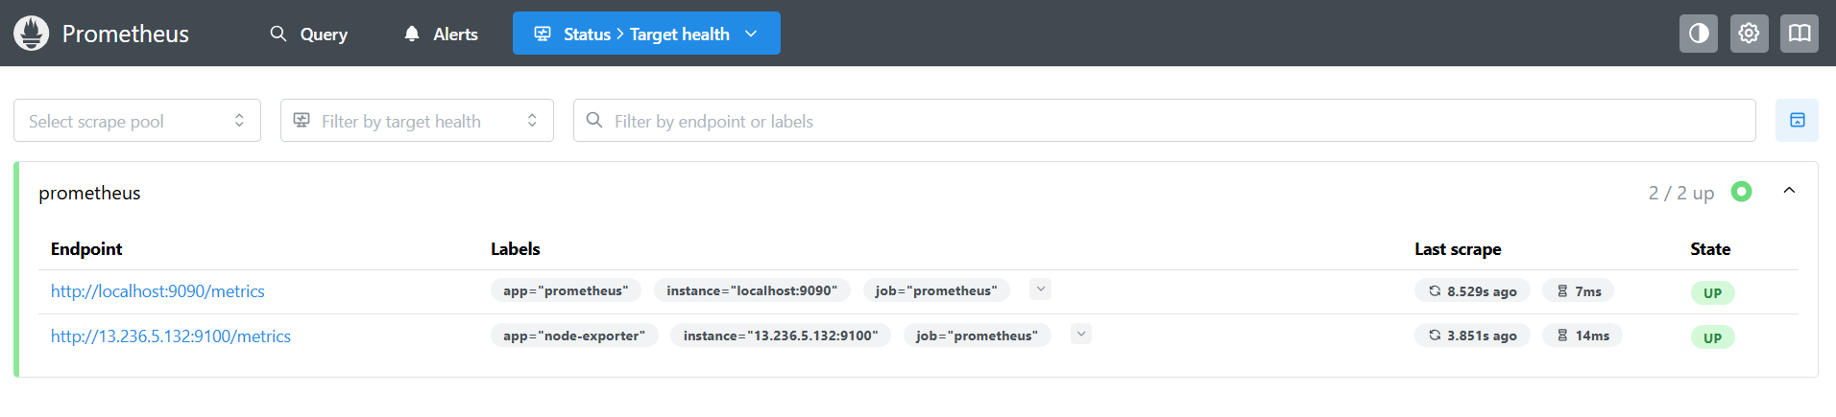
Grafana dashboard created
